<!DOCTYPE html>
<html>
<head>
<title>my</title>
</head>
<body>
<p align="right">my name is rahul verma</p>
</body>
</html>
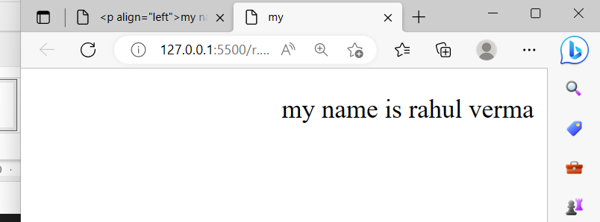

<!DOCTYPE html>
<html>
<body>
<img src="Game.png" width="200" hight="300">
</body>
</html>

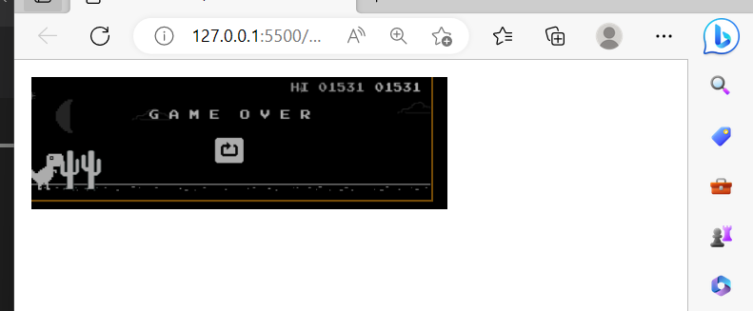

<!DOCYPTE html>
<html>
<head>
<title>file</title>
</head>
<body>
<a href="#mathematic's">Mathematic's</a><br>
<a href="#English">English</a><br>
<a href="#Html">HTML</a><br>
<a href="#c language">C LANGUAGE</a>
<a name="mathematic's"><h2>Mathematic's<h2></h2></a>
<p>Mathematic's Lorem ipsum dolor sit amet, consectetur adipisicing elit.<br><a href="n.html">top</a>
</p>
<a name="English"><h2>English</h2></a>
<p><strong>English</strong>is the most <em>popular</em>Lorem ipsum dolor, sit amet consectetur adipisicing elit. .<br><a href="n.html">Top</a>
</p>
<a name="Html"><h2>html(<em>hyper test markup language</em>)</h2></a>
<p><strong>html</strong> a shrothand for <i>hyper text markup language is one of the most important fundamental building blocks of the web. <STRONG><a href="n.html">Top</a></STRONG></em></i>
</p>
<a name="c language"><H2>C LANGUAGE</H2></a>
<p>in <em>1972</em> , c language is developed by denish richie for creating system applications such as driver, kernels etc <a href="n.html"><em>top</em></a></p>
</body>
</html>
>
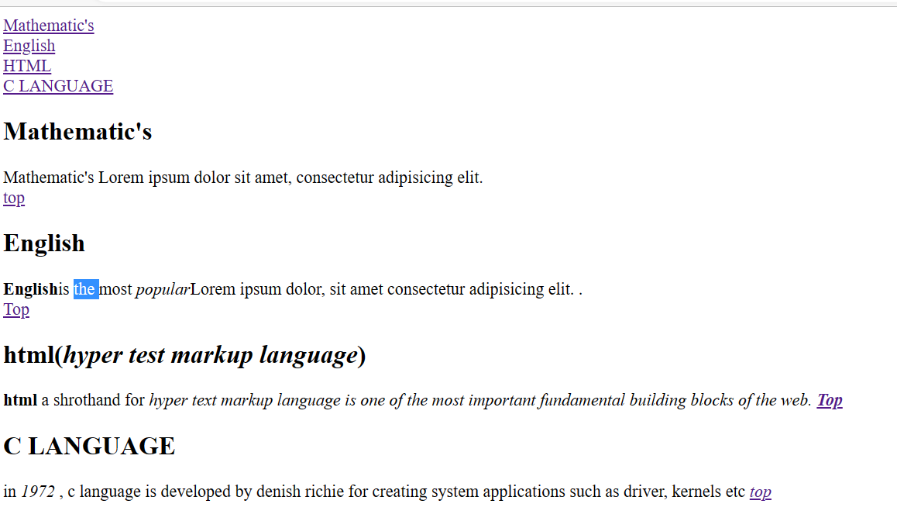
<!DOCTYPE html>
<html>
<head>
<title>
calcuter
</title>
</head><fieldset><legend> THIS IS A CALCULATOR</legend>
<form>
Enter the number : <input type="number" name="number"><br>
<table >
<tr><tb><button>9</button><button>8</button><button>7</button><button>%</button></tb></tr><br>
<tr><tb><button>8</button><button>7</button><button>6</button><button>*</button></tb></tr><br>
<tr><tb><button>3</button><button>2</button><button>1</button><button>/</button></tb></tr><br>
<tr><tb><button>=</button><button>+</button><button>-</button><button>Mg</button></tb></tr><br>

</table>
</form></fieldset>
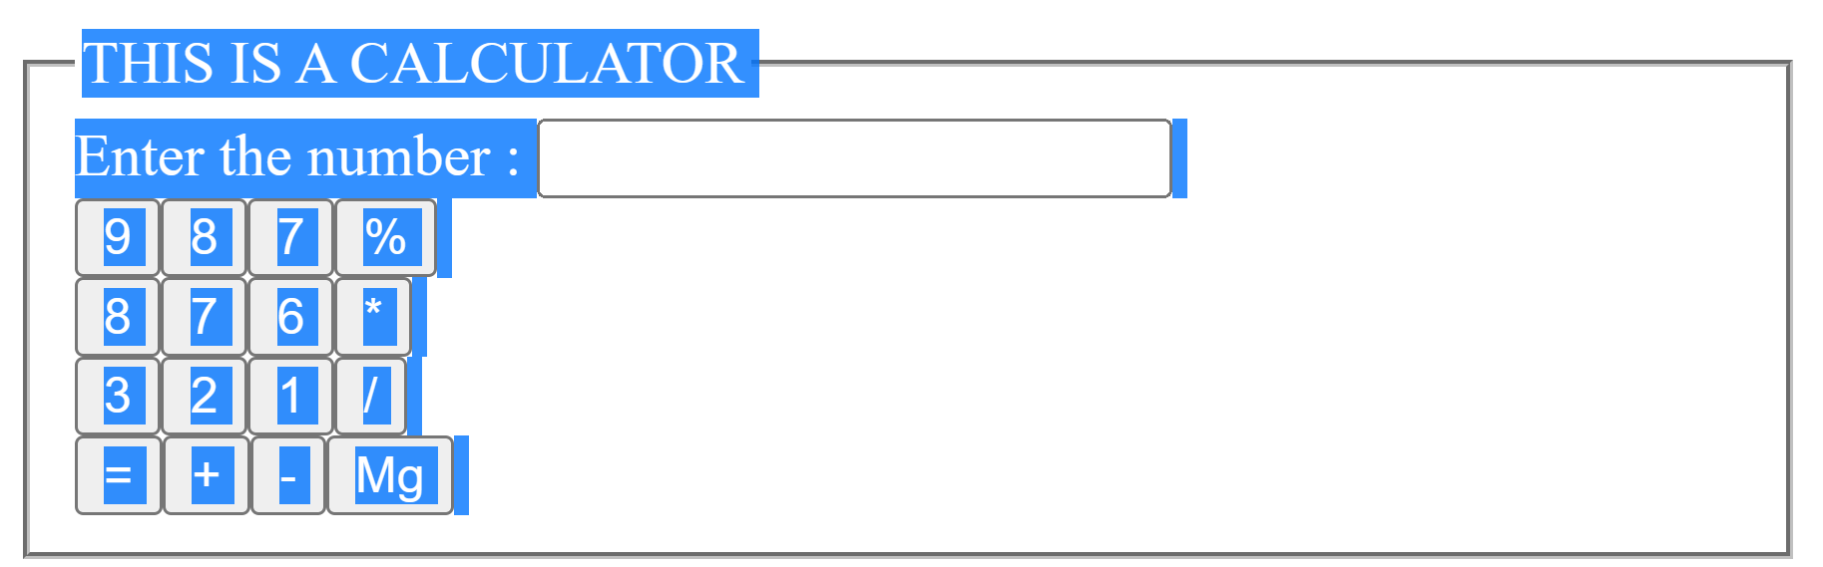
</html>
<!DOCTYPE html>
<html>
<head>
<title>
pratices
</title>
</head>
<body>
<form>
<p>Name : <input type="text" name="name" id="text" required placeholder="Enter your name" >
</p>
<p> Phone Number :<input type="phone number" name="number" id="phone number" required placeholder="Enter your phone number"></p>
<p> Address : <textarea cols="40px" rows="3px"required placeholder="Enter your current address"></textarea>
</p><fieldset>
<legend align="center"> Gender</legend>
<p><label for="femal"> <input type="radio" name="gender" id="femal" vlaue="Female"required >Female </label><label for="male">
<input type="radio" name="gender" id="male" value=""Male" required >Male </label>
</p></fieldset>
<fieldset>
<legend style="color: grey;">selected your subject for checkbox</legend>
<label for="Math"></p>
<p> <input type="checkbox" name="subject" value="Mathematic's" id="Math">Mathematic's</p>
</label>
<label for="C"></p>
<p> <input type="checkbox" name="subject" value="C language" id="C">C language</p>
</label>
<label for="hyper text markup language"></p>
<p> <input type="checkbox" name="subject" value="html" id="hyper text markup language">Html</p>
</label>
<label for="bc"></p>
<p> <input type="checkbox" name="subject" value="Buniess Communication" id="bc">Buniess Communicaion</p>
</label>
<label for="fundamental of computer"></p>
<p> <input type="checkbox" name="subject" value="foc" id="fundamental of computer">Foc</p>
<strong>selceted your city &nbsp;</strong>
<select name="city" >
<option value="Delhi">Delhi</option>
<option value="Banglore">Banglore</option>
<option value="Pune">Pune</option>
<option value="Mumbai">Mumbai</option>
<option value="Agra">Agra</option>

</select>

</label>
</fieldset>

<p> Password : <input type="password" name="user passward" id="passward"required placeholder="Ener the passward" ></p>
<p> E mail : <input type="Email" name="Email" id="passward"required placeholder="Enter the email"></p>
<p> Pin code : <input : type="number" name="pin code" id=" code"required placeholder="Enter the pin code">
<h3> payment detial's</h3>
<p> card type :
<select name="card_type" id="Card_type"required >
<option value="">--sected the card--</option>
<option value="mastercard">mastercard</option>
<option value="visa">upi</option>
<option value=" visa">visa</option>
</select>
</p>
<p> card number : <input type="number" name="card number" id="number"required placeholder="Enter your card number"></p>
<P> Expiration date : <input required type="date" name="Expiration date" id="Expiration date" ></P>
<p> cvv <input type="password" name="cvv" id="cvv" placeholder="Enter Card Verification Value"></p>
<p> <input TYPE="SUBMIT" value="pay"> </p>

<p> <input type="reset" name="reset" id="reset" required ></p>
<p> <input type="submit" name="submit" id=" submit form"required > </p>
</p>
</form>
</body>
<html>

